FILL IN : Docker pt. 1
Pierre Semay

Questions from the lab
Question 1: Add comments to dockerfile
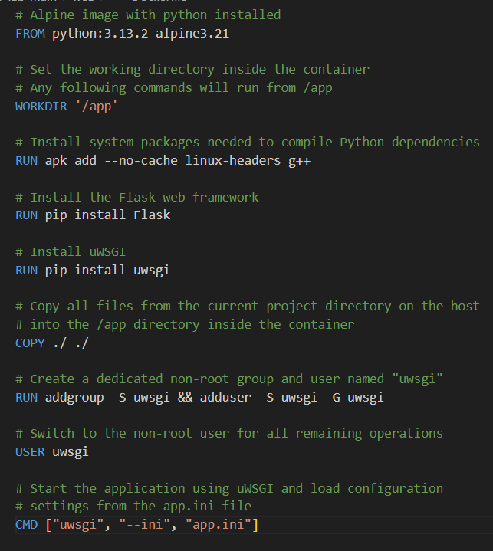
Question 2: command to build image
Docker build .

Question 3: Reducing build layers

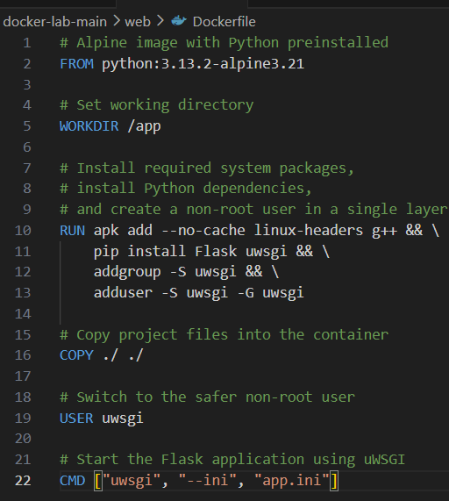
All the “run” commands can be combined into 1 layer
Question 4: Name the build
docker build -t pierre/frontend .
Question 5: What does the -p and -it (can also be written as -i -t) flags do?
-p is port
-it is interactive terminal
Question 6: is the build process fast?
Not very
Question 7: Optimised dockerfile
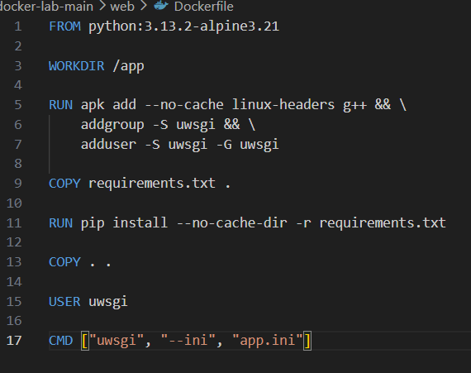
Question 7: prestarrt.sh
Shebang line
Update database to latest migration
Pass all other given arguments

Heb hierna errors gekregen wanneer ik probeerde de postgres container en api container samen te gebruiken. Heb dit niet kunnen oplossen dus de laatste stap hierna heb ik niet kunnen doen.

Questions to answer for every lab
What did you learn?
Fill in your three take aways that you learned during this lesson.
How to build and run Docker containers using docker build and docker run
How a Dockerfile works
Give three interesting exam questions about the contents of the lab and/or the theory.
Thinking about this will make sure you remember the key take-aways and important details better and longer.
What is the difference between a Docker image and a Docker container
Explain the purpose of the instructions in a Dockerfile.
Why is it useful to reduce the number of layers in a Docker image
Check the following:
- I have made the entire lab assignment (be careful, some labs consist out of two or more Notion documents!).
- I have answered all the questions from the lab assignment.
- I have submitted my code as a zip file and/or as a link to a public Git repository.
- <For labs on Azure> I have shut down any resources that are in use, in order to avoid unexpected costs.

